Name: ch.ishwarya  
reg no: 192372104  
course: csa1409 – compiler design

1) Write a LEX program to implement basic mathematical operations.

Program:

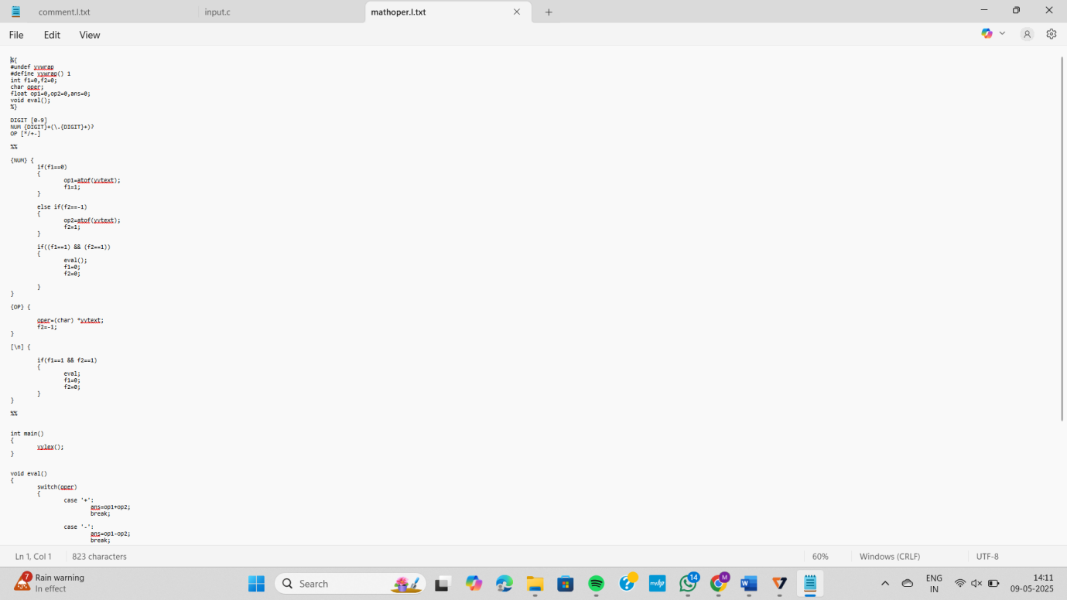

Output:

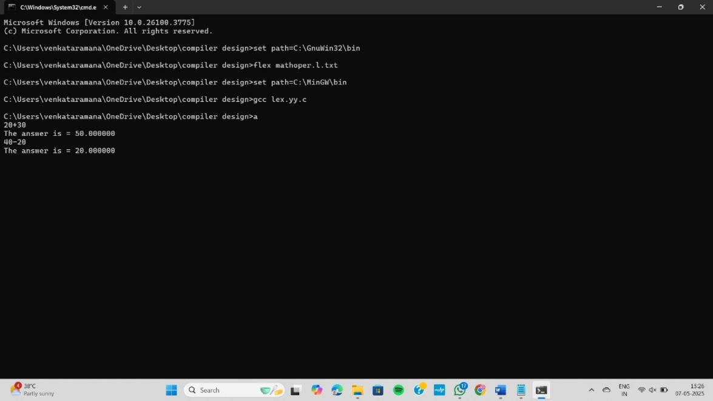

2) Write a LEX program to check whether the given input is digit or not.

Program:

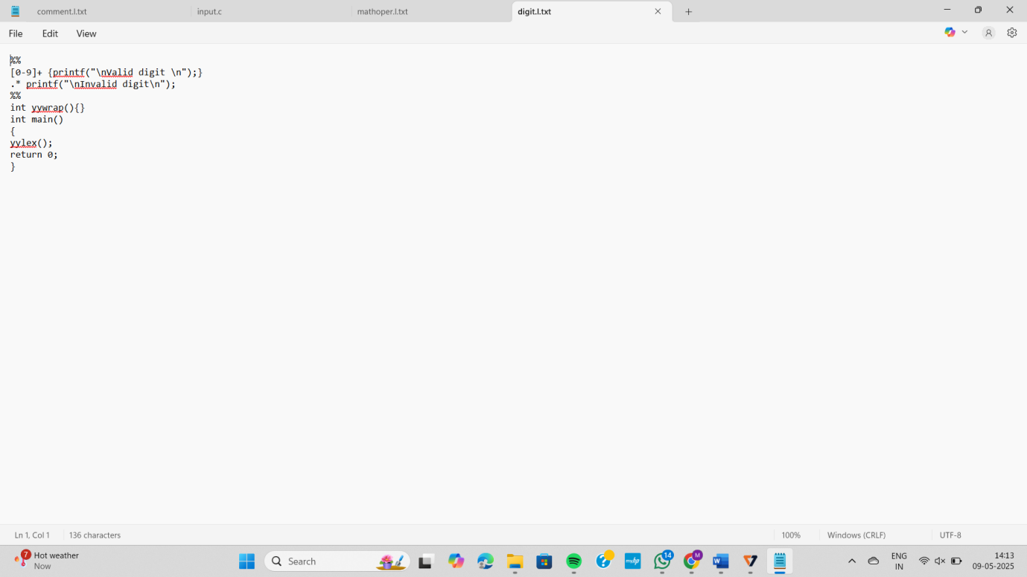

Output:

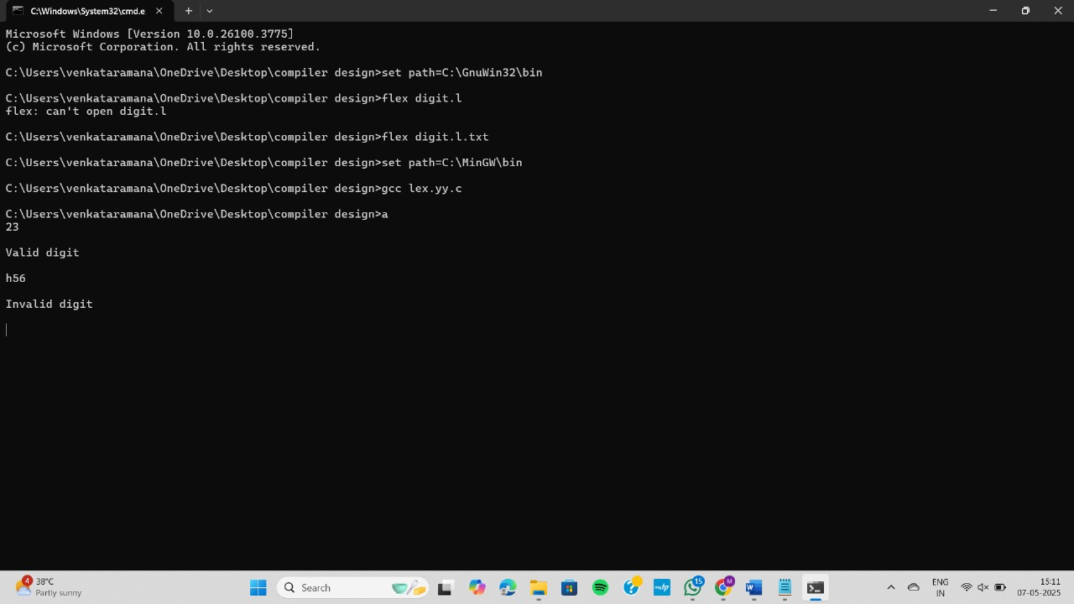

3) Write a LEX program to validate DOB of students.

Program:

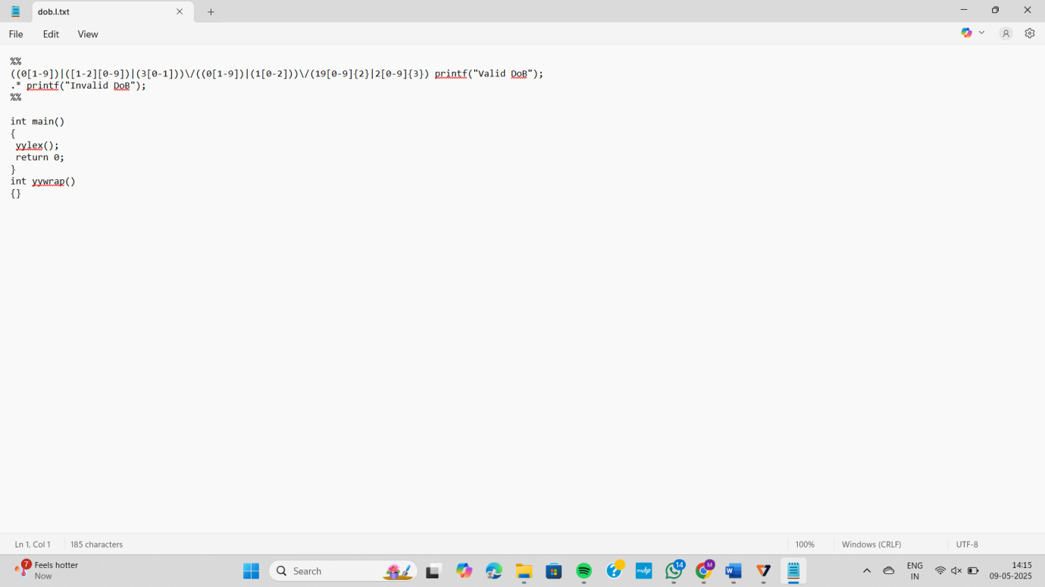

Output: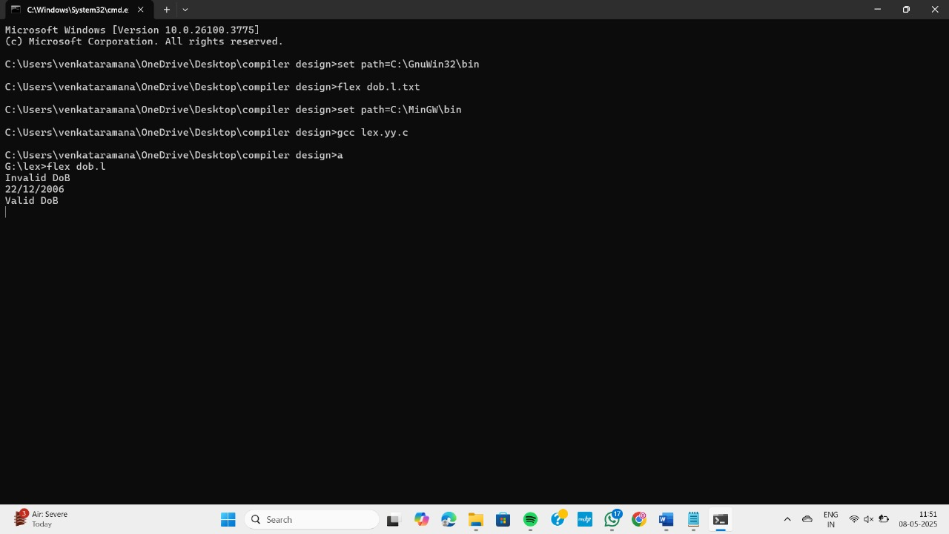

4) Write a LEX program to validate the URL.

Program:

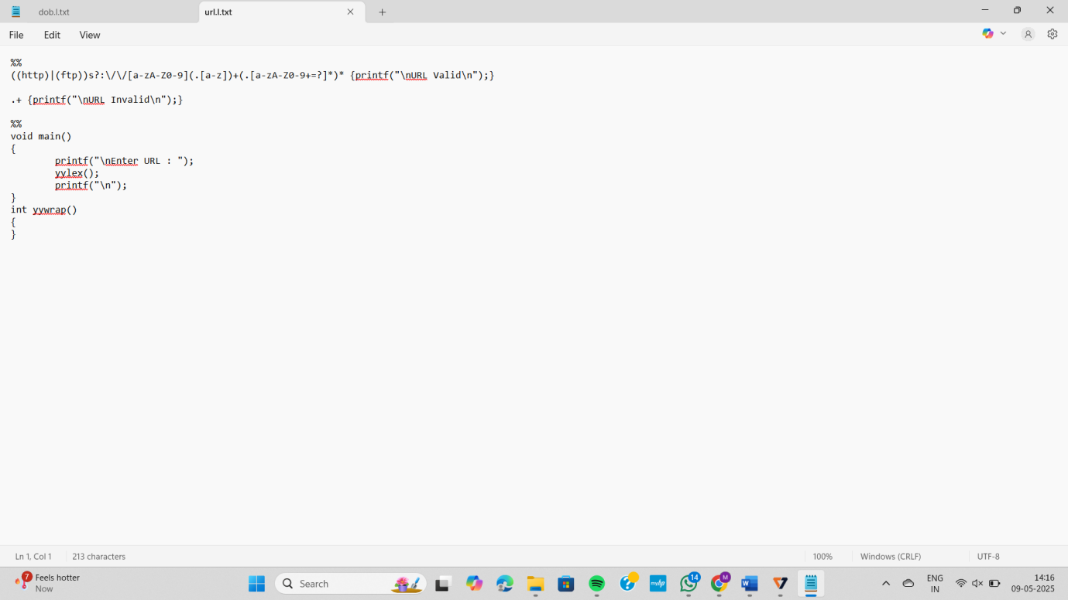

Output:

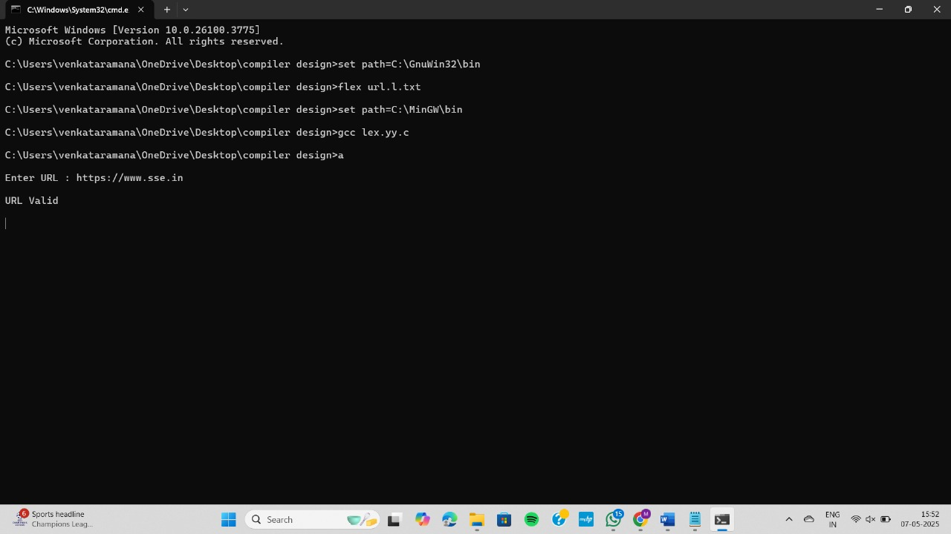

5) Write a LEX program to identify and count positive and negative numbers.

Program:

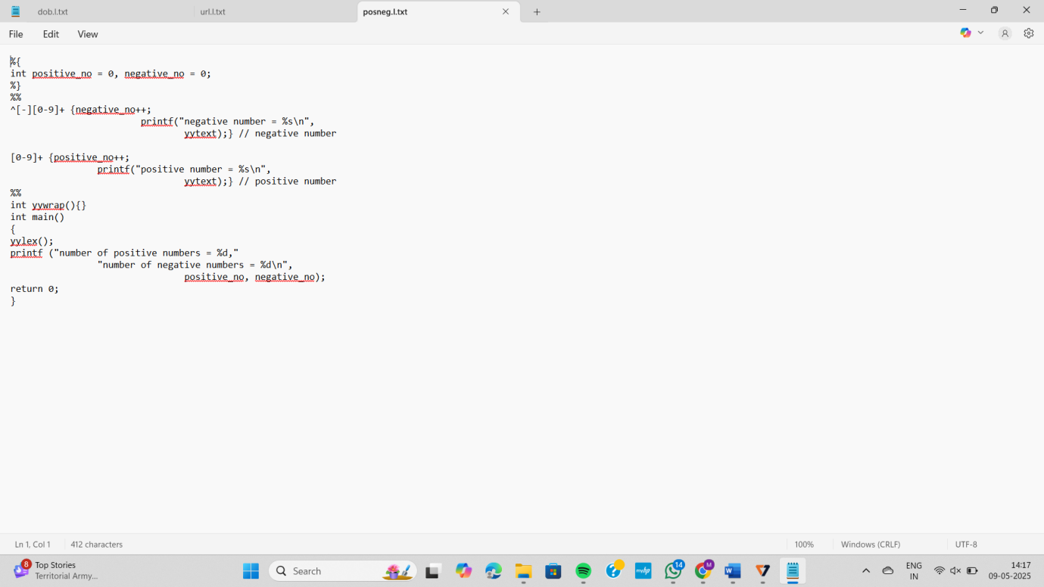

Output:

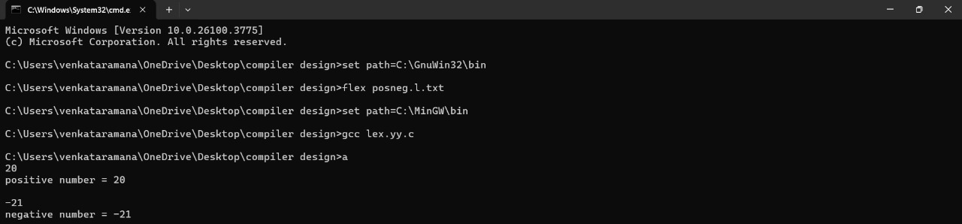

6) Write a LEX program to recognise numbers and words in a statement.

Program:

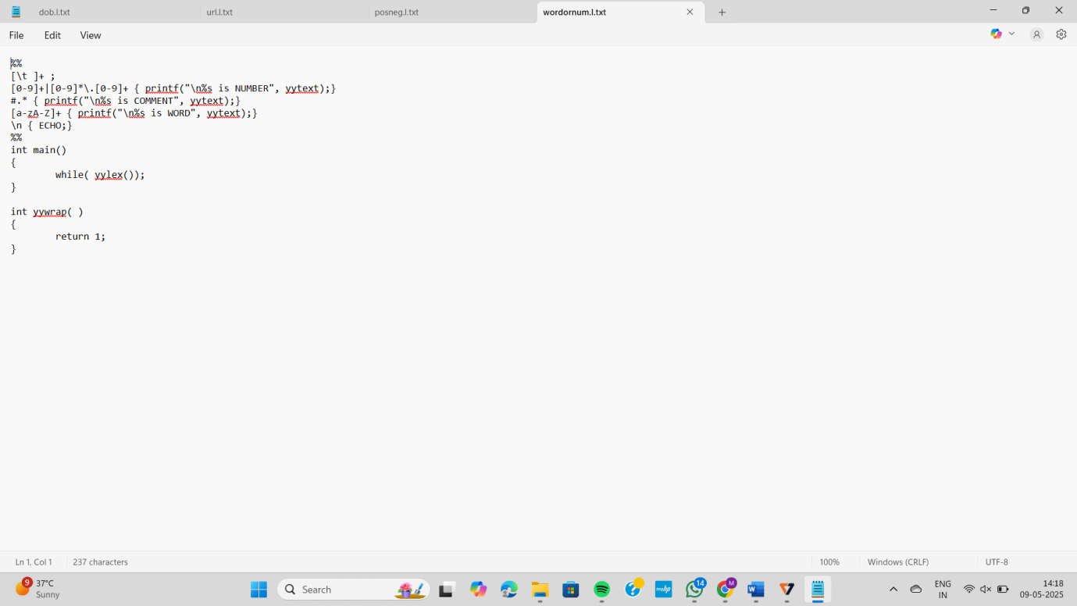

Output:

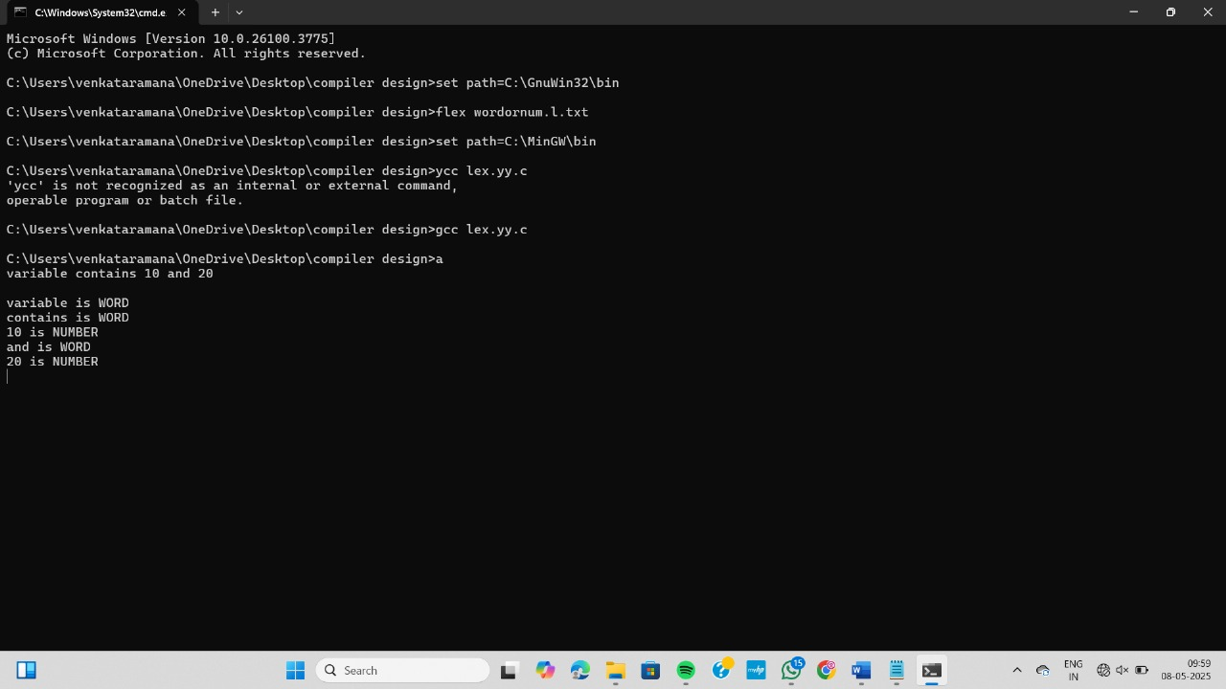

7) Write a LEX program to separate the keywords and identifiers.

Program:

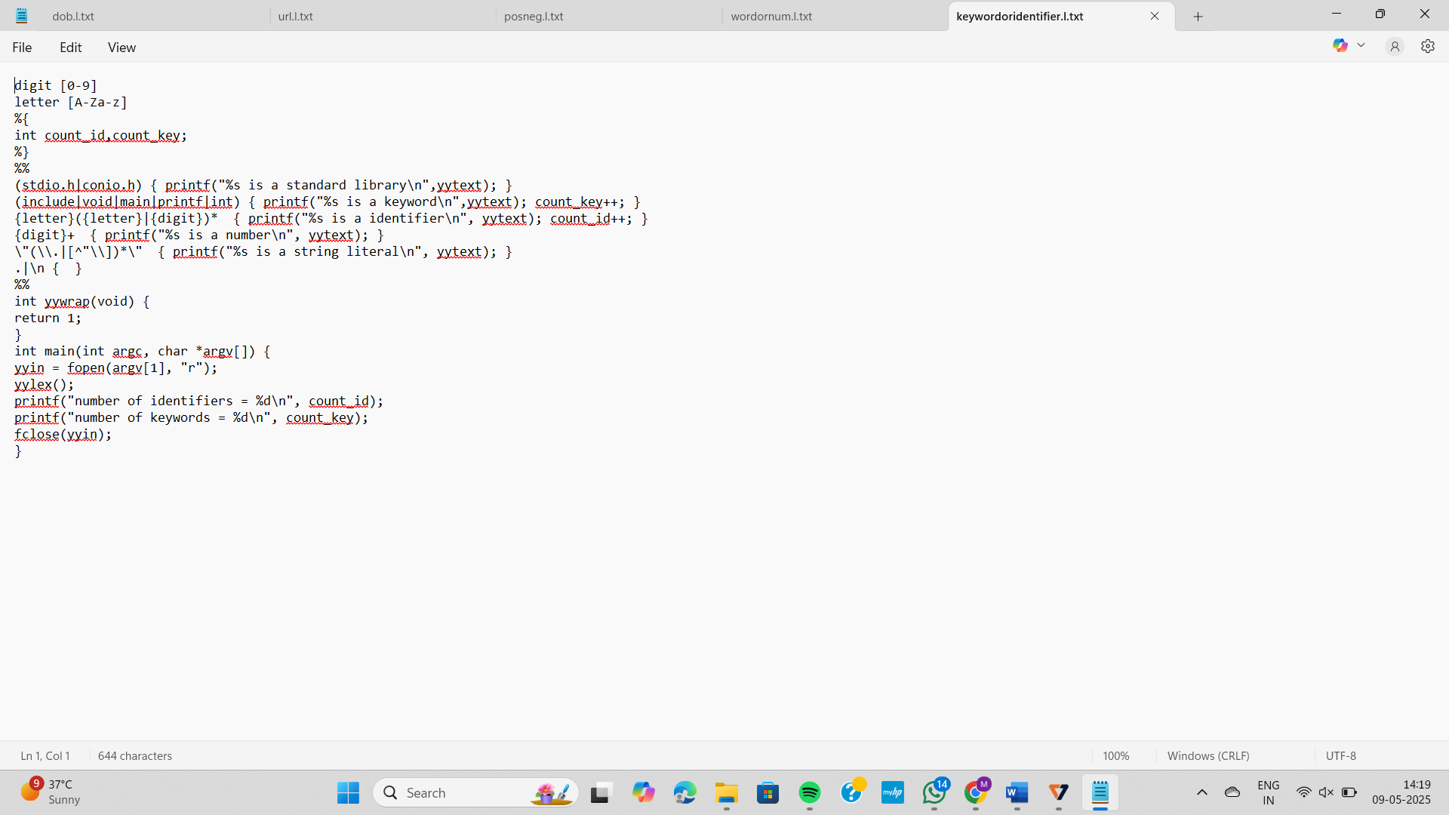

Output:

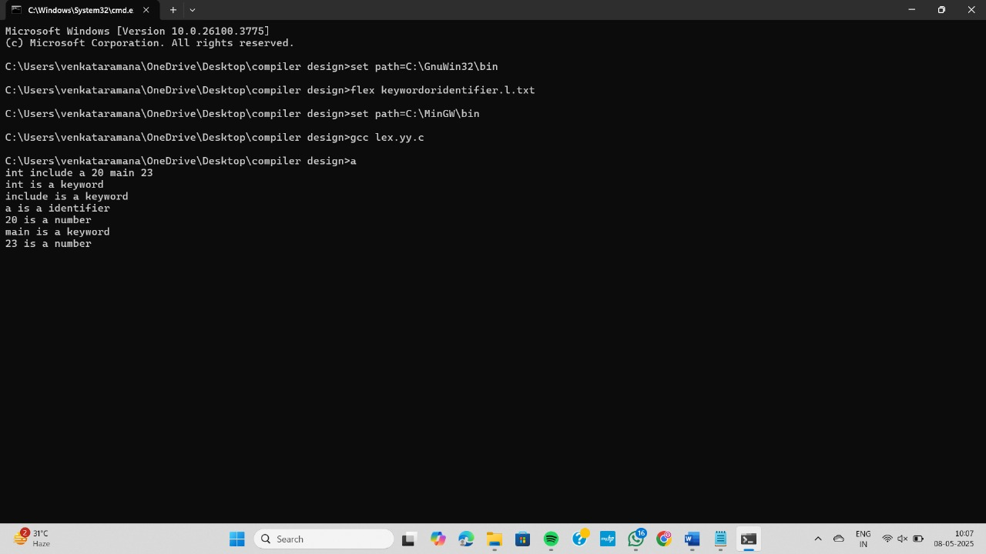

8) Write a LEX program to count the number of vowels in the given sentence.

Program:

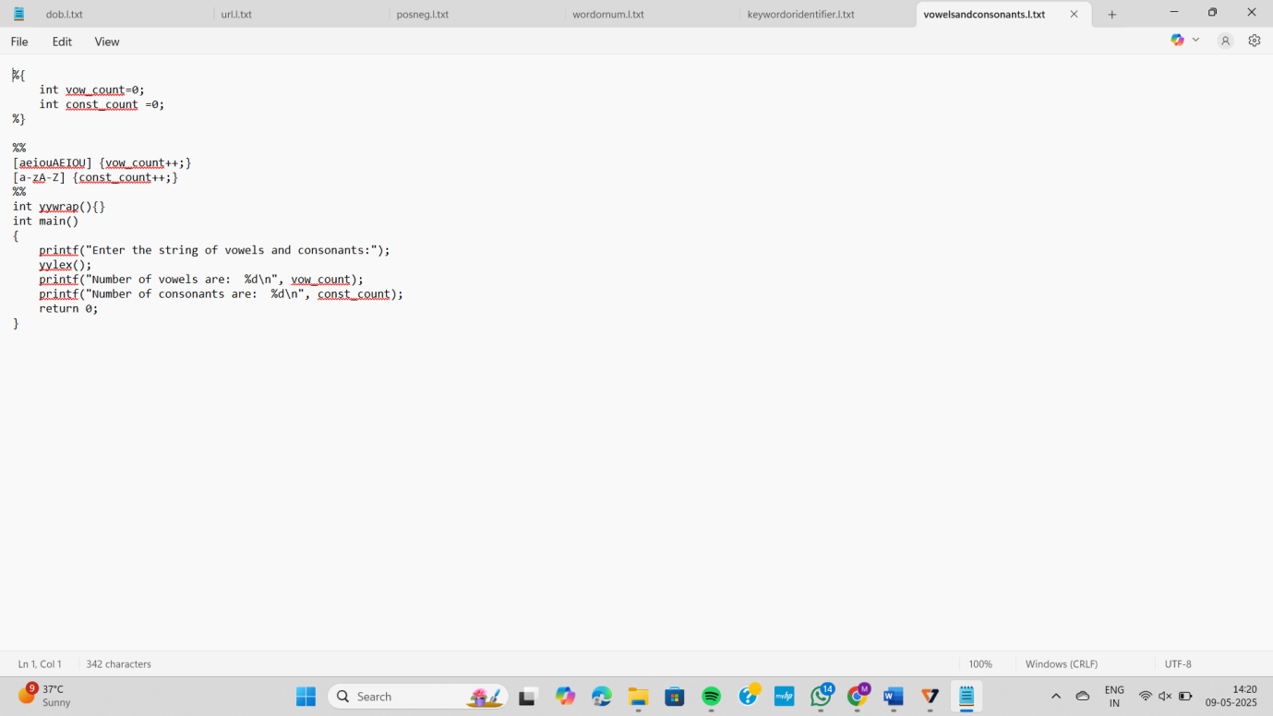

Output:

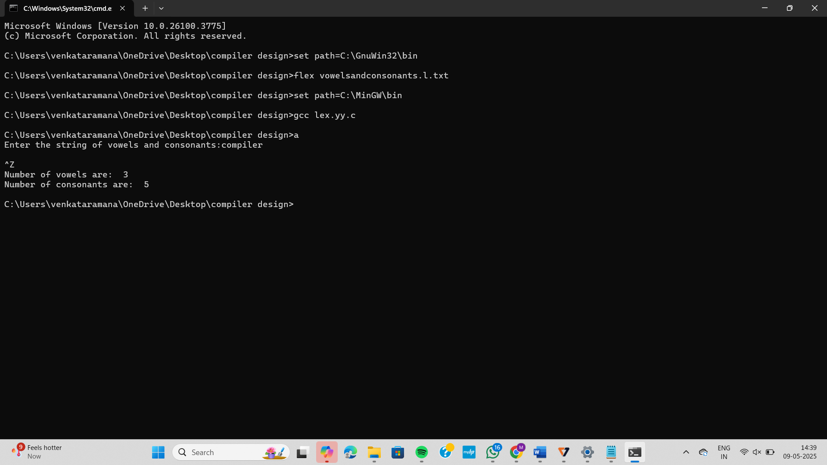

9) Implement a LEX program to check whether the mobile number is valid or not.

Program:

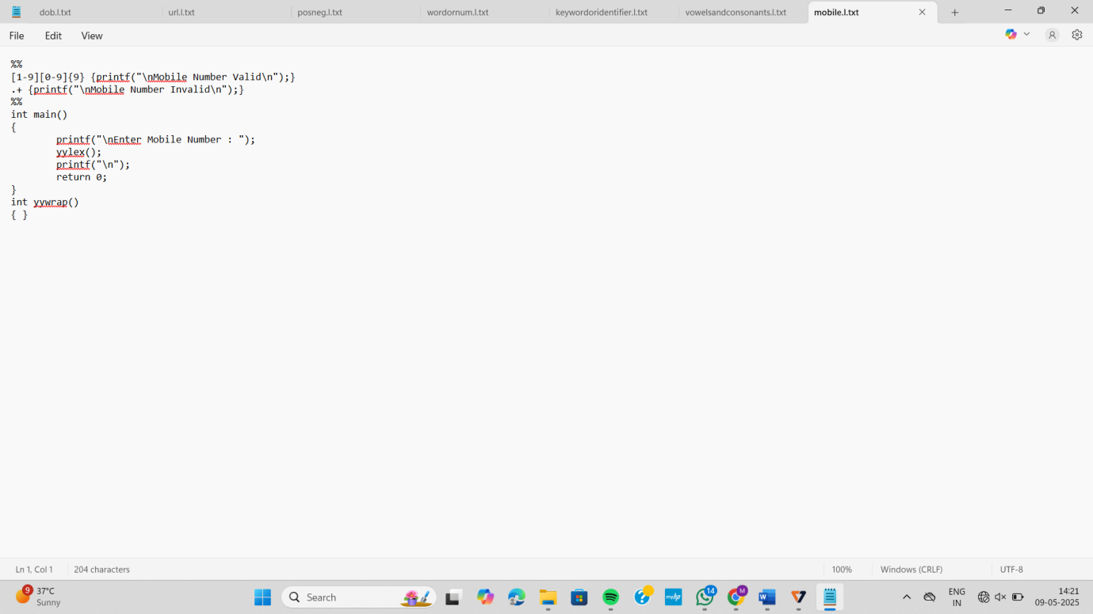

Output:

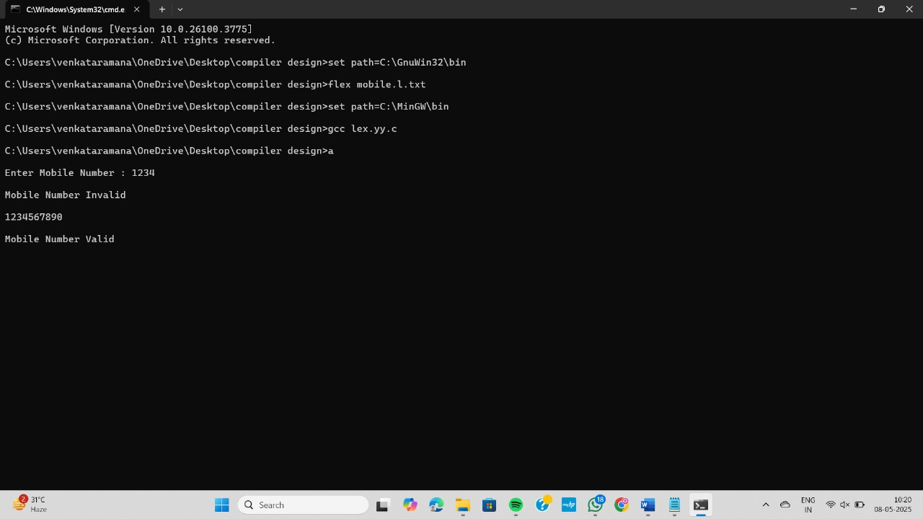

10) Write a LEX Program to convert the substring abc to ABC from the given input string

Program:

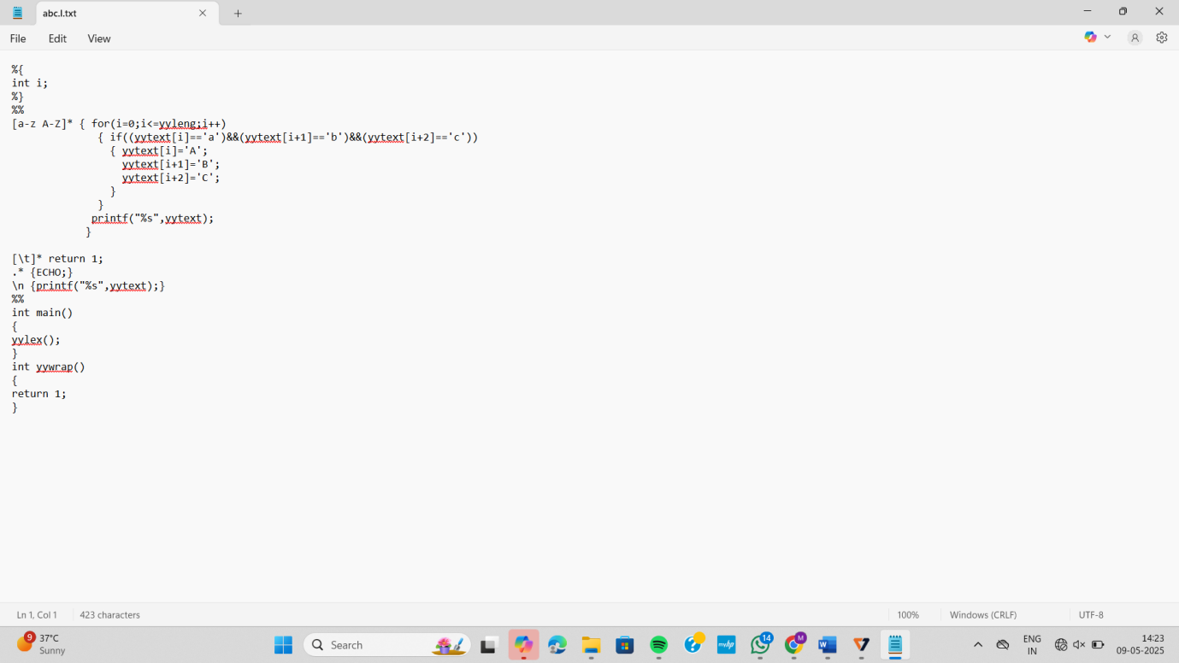

Output:

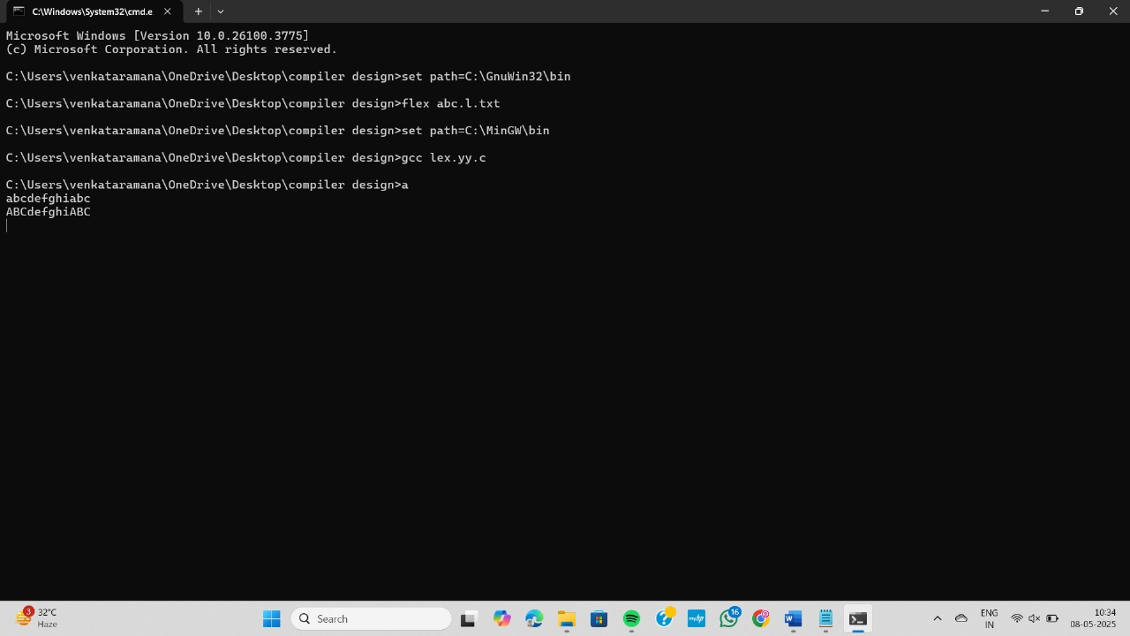

11) Write a LEX Program to check the email address is valid or not.

Program:

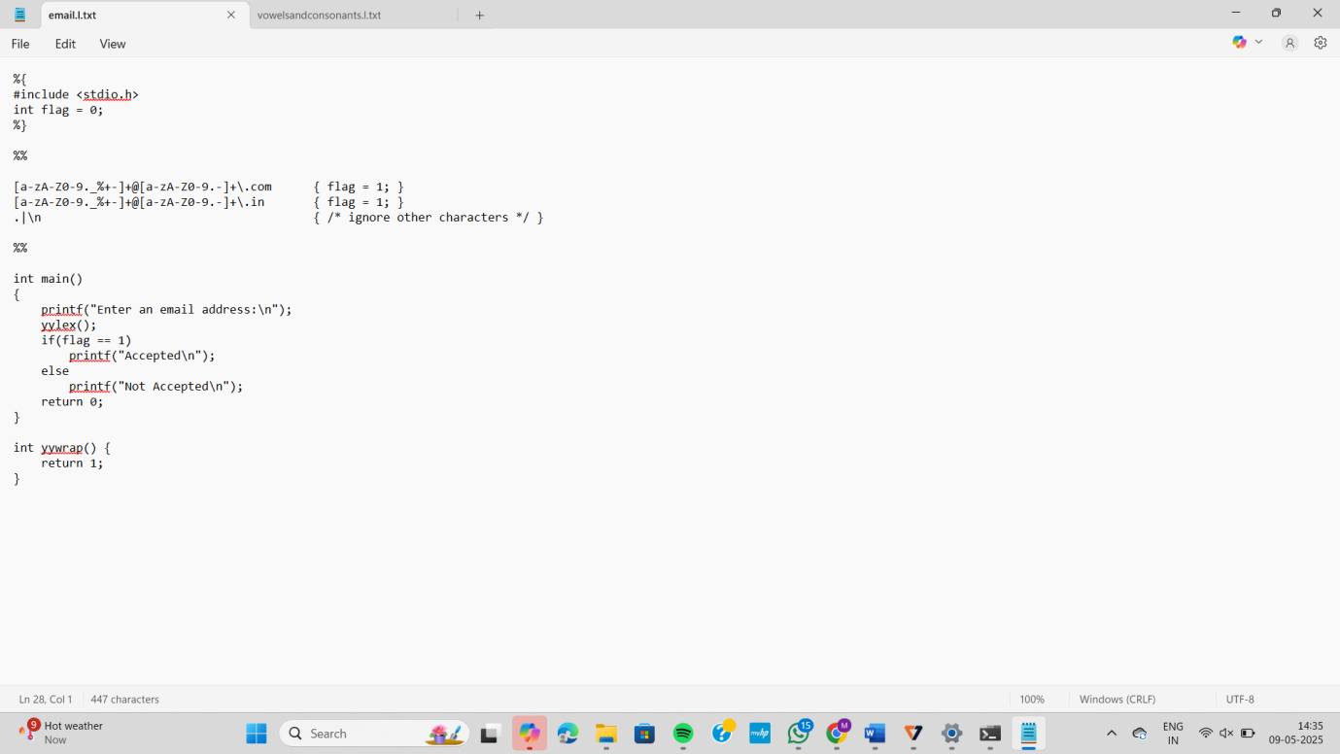

Output:

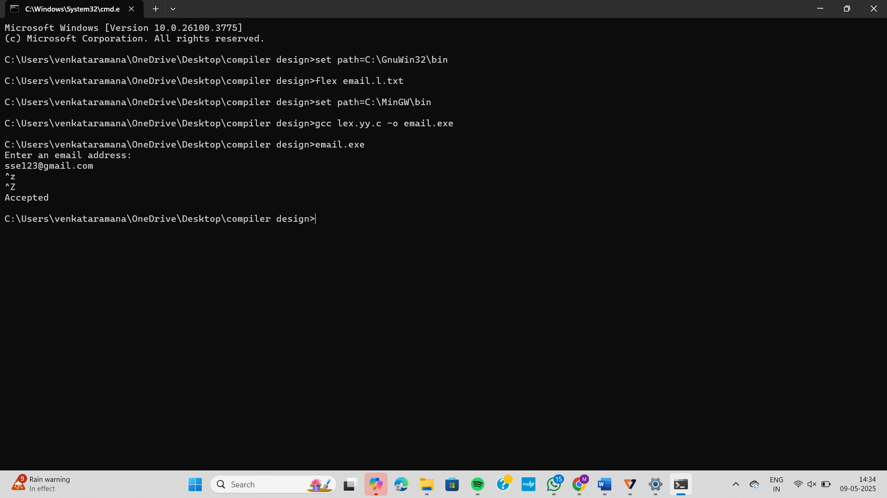

12) Write a LEX program to identify the capital words from the given input.

Program:

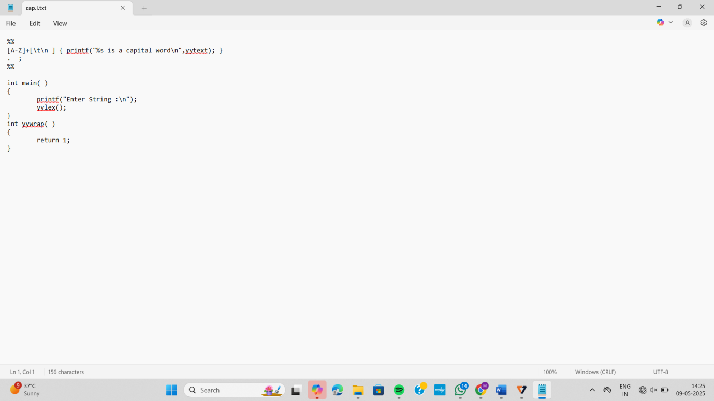

Output:

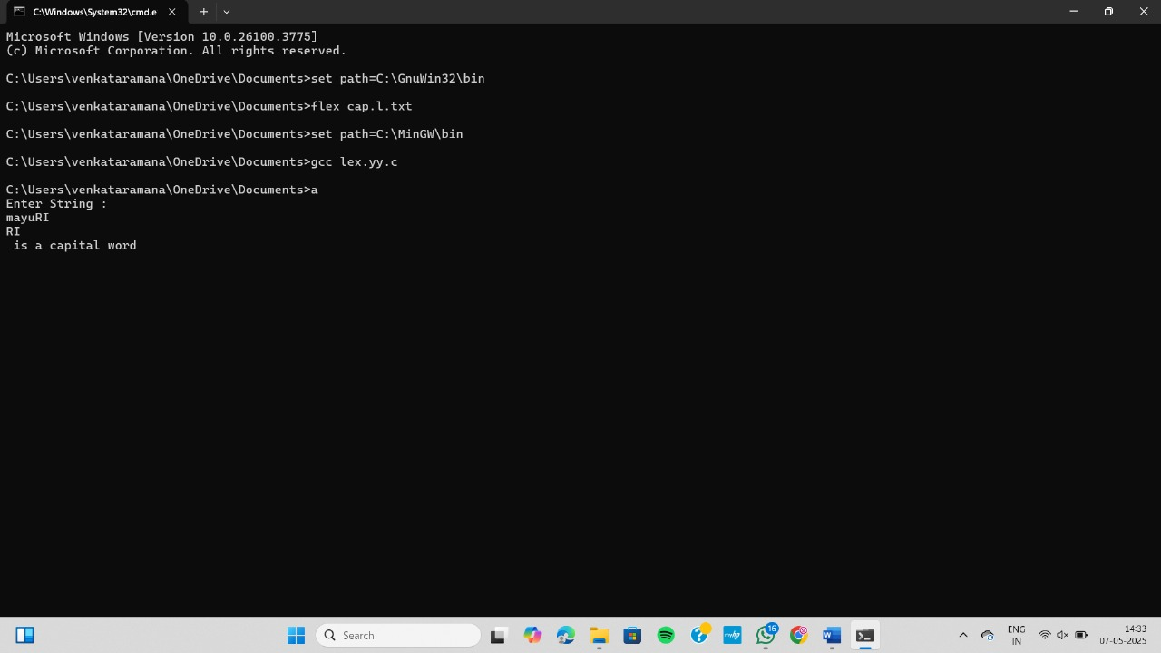

13) Write a LEX program to count the number of comment lines in a given C program and eliminate them and write into another file.

Program:

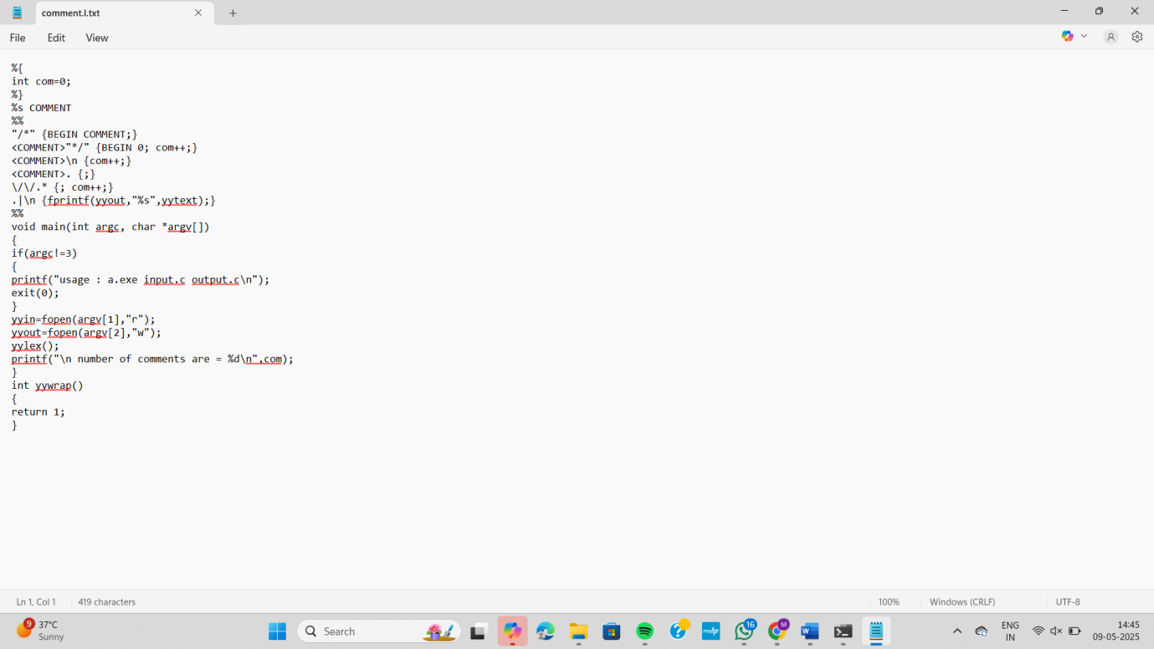

Output:

